

|  |
| --- |
| Riga Business School  Functional and Technical Specification Document  <Bauska Carreer Navigator> |

**DOCUMENT VERSION 0.2**

**12/11/2019**

|  |  |  |
| --- | --- | --- |
| **Name** | **Role** | **Department** |
| Germans Repņikovs | Project manager | Project Management |
| Rustam Nilobekov | Project manager | Project Management |
| Oleg Evteev | Customers & communication | Public relations |
| Edvīns Rjabcevs | Customers & communication | Public relations |
| Ksenija Madžule | Design & user experience | Website Design |
| Niklāvs Pauls Lībers | Design & user experience | Website Design |
| Antons Jaroslavcevs | Software | IT |
| Elizabete Livdāne | Software | IT |

**AUTHORS**

**DOCUMENT HISTORY**

|  |  |  |  |
| --- | --- | --- | --- |
| **Date** | **Version** | **Document Revision Description** | **Document Author** |
| 12.11.2019 | 0.2 |  |  |
|  |  |  |  |

## Purpose of the document

This document is designed for team members and project overseers, so they understand what our product will be like and how it will work. The information placed below can be changed.

## Project Scope

Future path orientation platform/ website which supposed to give the future career orientation and propose relevant universities/colleges and their courses. Our main intention in this project is to make a website where one can see a list of universities and pass a career orientation test.

## 1.2 Terms/Acronyms and Definitions

|  |  |  |
| --- | --- | --- |
| **Term/Acronym** | **Definition** | **Description** |
|  |  |  |

## Risks and Assumptions

1.A few people will know about this webpage. Consequently, nobody will use Bauska Career Navigator.

2.Test won’t work in proper way and will give wrong answers and directions.

# System/ Solution Overview

On Bauska Career Navigator web site, the user has the opportunity to receive assistance in the field of career choice. The site will consist of one long page, and two separate. Having visited the site, the user has the opportunity to learn about web site, its functions, and goals. Further, he/she will be step-by-step painted instructions on this site. There will also be a 'Get Get Started' button, by clicking on which he goes to another page. There will be a test where the user will answer questions related to career choice. According to the test results, the student will be presented with possible options for the faculties that are suitable for him, as well as with universities in Latvia where he can study. In addition, there will be a page on which all possible training options in Latvia and their cost will be painted.

## 2.1 System Actors

### 2.2.1 User Roles and Responsibilities / Authority Requirements

|  |  |  |
| --- | --- | --- |
| **User/Role** | **Example** | **Additional Notes** |
| User | Secondary school absolvent | Will be able to visit web page, see all information, complete test, receive results of the test. (unable to adjust or add information visible on the homepage) |
| Web page developer | Antons Jaroslavcev | Will check and improve webpage functionality. |

## 3 Title - Bauska Career Navigator

### 3.1 Purpose/ Description

Our team has changed its direction a bit, so the test will not be the key and most crucial part of our site. The crucial part is a list of faculties available in Latvia, among with brief essential information about them (pricing, location, language, scholarship opportunities). The data will be imported manually from each university website and placed on our webpage in convenient way.

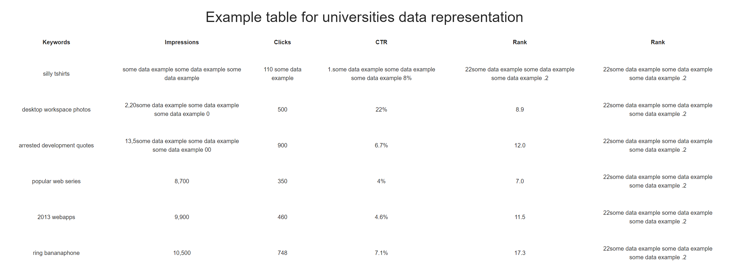

On the web site, in the step by step section, instructions for using the website and navigation, which leads to the test, will be written. Our photograph of the design shows only a sample of it. Next, a text will be invented in which it will be written what the user needs to do. And immediately after this section, there will be a button “Take the test”, after which the user will be taken to the page with the test.

# 3.2 System Configurations

Once on the test page, the user will see a brief description of how he needs to answer the questions presented to him. All test questions will be reflected immediately on the page. The question will be indicated, and below the yes or no button will be, which he will click on, based on his choice. After answering all questions (approximately 40 questions), there will be a button "Save Results". After the user clicks on it, a new page with the results will appear in front of him. On this page, a list of faculties that are suitable for the user based on the results will be indicated. Near the faculties will be indicated the universities of Latvia, in which you can get this education. And links to university pages. Now we are planning to make another webpage (because it will be both more practical and easier from a programmer’s perspective) with university info, as on a screenshot above.

**3.3 Webpage Hosting**

The website on current stage is hosted on Github.com, later we will buy a hosting and a domain in future.

# 3.4 The test (which will be located on the website)

The test RIASEC will be adopted from a pdf-format found online:

<https://www.hawaiipublicschools.org/DOE%20Forms/CTE/RIASEC.pdf>

For test calculations, we will use a server-hosted JS function, that inputs user’s answers and outputs the result. The results will not be stored. Question order will not be randomised. There are 6 types of questions, each YES answer will add +1 to a corresponding variable. 42 questions in total. Programming-wise: bunch of if statements.

* 1. **Field level specifications**

Website’s front-end will consist of four HTML pages:

* Long primary page.
* Page with list of universities
* Test page, where the user can fill out the answers
* Result page, where the user can see the outcome of his answers

HTML, pages will be adjusted using CSS and built using Bootstrap 4

Data about universities either going to be entered manually into HTML file, or inputted to website automatically from database, that we will make.

### Mock-up

 